Image Classification – Deep Learning Project in Python with Keras

Image classification is a fascinating deep learning project. Specifically, image classification comes under the computer vision project category.

In this project, we will build a convolution neural network in Keras with python on a CIFAR-10 dataset. First, we will explore our dataset, and then we will train our neural network using python and Keras.

What is Image Classification?

* The classification problem is to categorize all the pixels of a digital image into one of the defined classes.
* Image classification is the most critical use case in digital image analysis.
* Image classification is an application of both supervised classification and unsupervised classification.
  + In supervised classification, we select samples for each target class. We train our [neural network](http://news.mit.edu/2017/explained-neural-networks-deep-learning-0414) on these target class samples and then classify new samples.
  + In unsupervised classification, we group the sample images into clusters of images having similar properties. Then, we classify each cluster into our intended classes.

About Image Classification Dataset

CIFAR-10 is a very popular computer vision dataset. This dataset is well studied in many types of deep learning research for object recognition.

This dataset consists of 60,000 images divided into 10 target classes, with each category containing 6000 images of shape 32*32. This dataset contains images of low resolution (32*32), which allows researchers to try new algorithms. The 10 different classes of this dataset are:

1. Airplane
2. Car
3. Bird
4. Cat
5. Deer
6. Dog
7. Frog
8. Horse
9. Ship
10. Truck

CIFAR-10 dataset is already available in the datasets module of Keras. We do not need to download it; we can directly import it from keras.datasets.

Project Prerequisites:

The prerequisite to develop and execute image classification project is [Keras and Tensorflow installation](https://data-flair.training/blogs/install-keras-on-linux-windows/).

Steps for image classification on CIFAR-10:

1. Load the dataset from keras datasets module

from keras.datasets import cifar10

import matplotlib.pyplot as plt

(train_X,train_Y),(test_X,test_Y)=cifar10.load_data()

2. Plot some images from the dataset to visualize the dataset

n=6

plt.figure(figsize=(20,10))

**for** i **in** range(n):

plt.subplot(330+1+i)

plt.imshow(train_X[i])

plt.show()

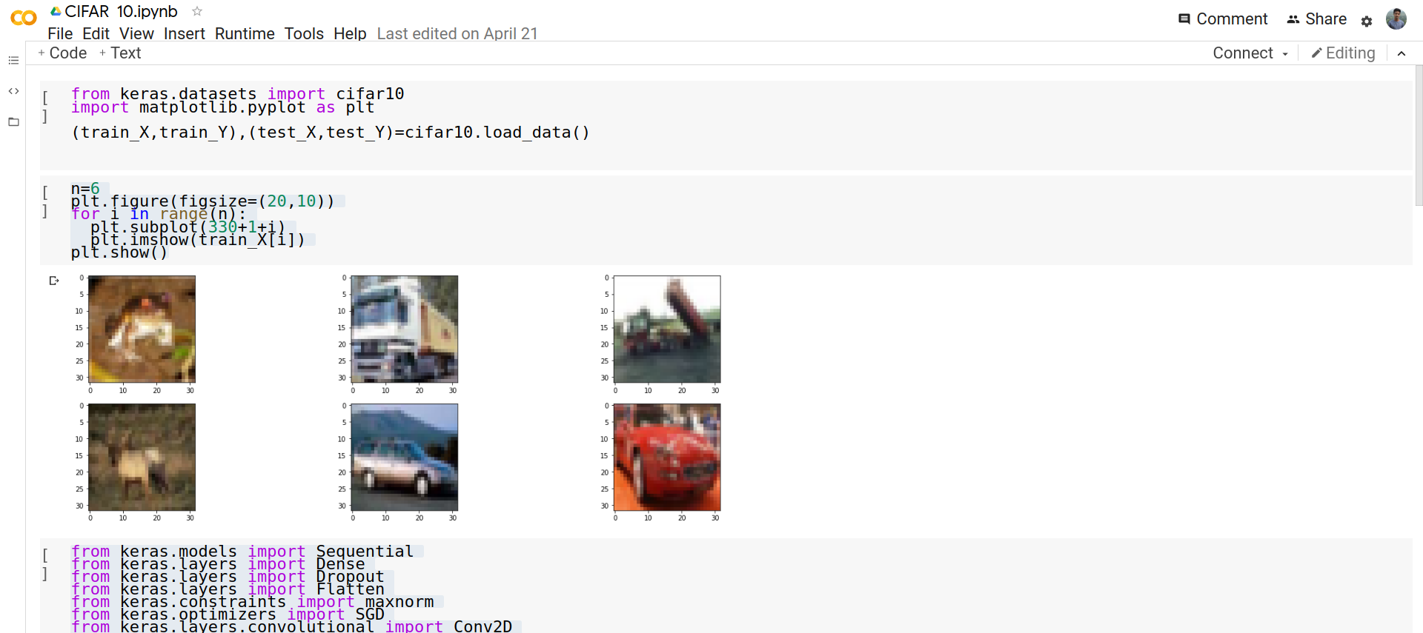

3. Import the required layers and modules to create our convolution neural net architecture

from keras.models import Sequential

from keras.layers import Dense

from keras.layers import Dropout

from keras.layers import Flatten

from keras.constraints import maxnorm

from keras.optimizers import SGD

from keras.layers.convolutional import Conv2D

from keras.layers.convolutional import MaxPooling2D

from keras.utils import np_utils

4. Convert the pixel values of the dataset to float type and then normalize the dataset

train_x=train_X.astype('float32')

test_X=test_X.astype('float32')

train_X=train_X/255.0

test_X=test_X/255.0

5. Now perform the one-hot encoding for target classes

train_Y=np_utils.to_categorical(train_Y)

test_Y=np_utils.to_categorical(test_Y)

num_classes=test_Y.shape[1]

6. Create the sequential model and add the layers

model=Sequential()

model.add(Conv2D(32,(3,3),input_shape=(32,32,3),

padding='same',activation='relu',

kernel_constraint=maxnorm(3)))

model.add(Dropout(0.2))

model.add(Conv2D(32,(3,3),activation='relu',padding='same',kernel_constraint=maxnorm(3)))

model.add(MaxPooling2D(pool_size=(2,2)))

model.add(Flatten())

model.add(Dense(512,activation='relu',kernel_constraint=maxnorm(3)))

model.add(Dropout(0.5))

model.add(Dense(num_classes, activation='softmax'))

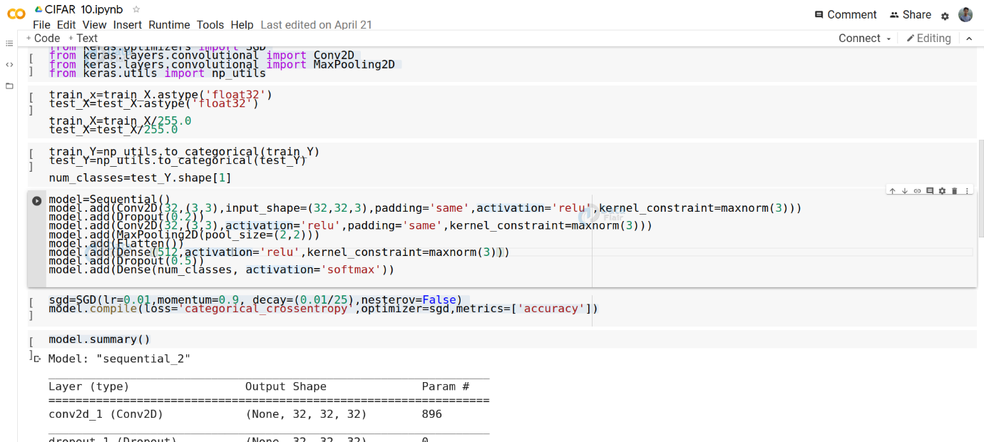

7. Configure the optimizer and compile the model

sgd=SGD(lr=0.01,momentum=0.9,decay=(0.01/25),nesterov=Fals)

model.compile(loss='categorical_crossentropy',

optimizer=sgd,

metrics=['accuracy'])

8. View the model summary for better understanding of model architecture

model.summary()

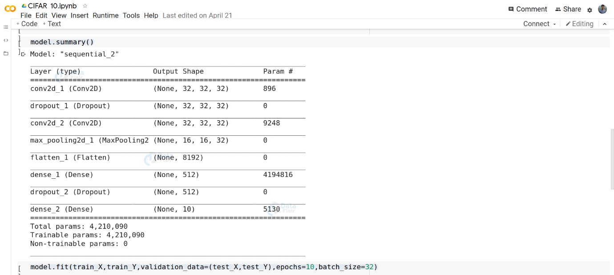

9. Train the model

model.fit(train_X,train_Y,

validation_data=(test_X,test_Y),

epochs=10,batch_size=32)

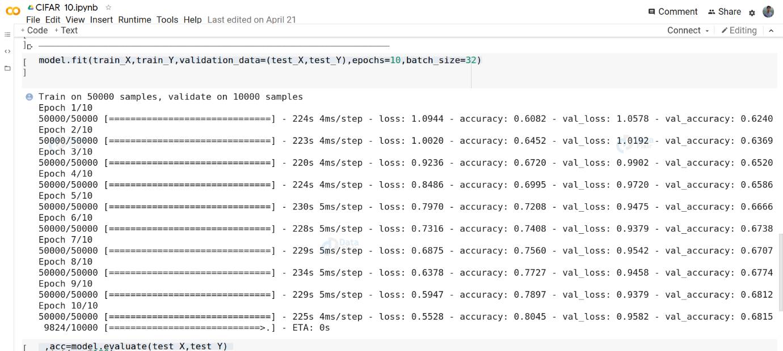

10. Calculate its accuracy on testing data

_,acc=model.evaluate(test_X,test_Y)

print(acc*100)

11. Save the model

model.save("model1_cifar_10epoch.h5")

12. Make a dictionary to map to the output classes and make predictions from the model

results={

0:'aeroplane',

1:'automobile',

2:'bird',

3:'cat',

4:'deer',

5:'dog',

6:'frog',

7:'horse',

8:'ship',

9:'truck'

}

from PIL import Image

import numpy as np

im=Image.open("__image_path__")

# the input image is required to be in the shape of dataset, i.e (32,32,3)

im=im.resize((32,32))

im=np.expand_dims(im,axis=0)

im=np.array(im)

pred=model.predict_classes([im])[0]

print(pred,results[pred])

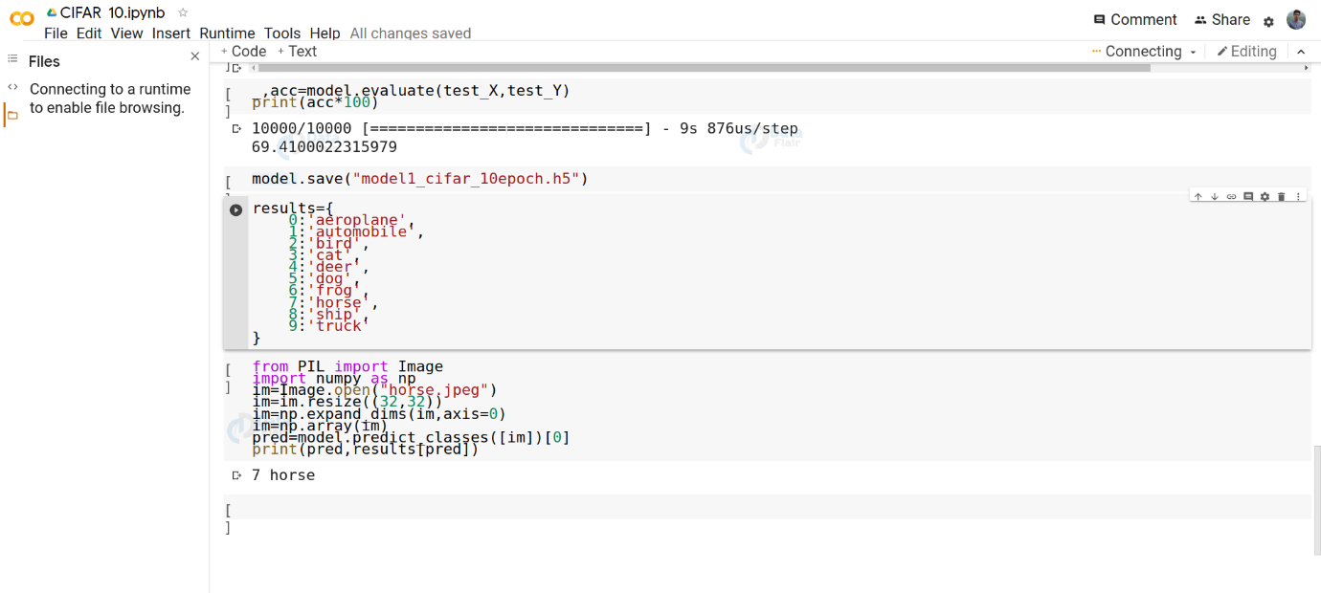

You can test the result on your custom image input. To improve accuracy, try increasing the epoch count to 25 for training.

Image Classification Project GUI

Here, we will build a graphical user interface for our image classifier. We will build this GUI using [Tkinter](https://docs.python.org/3/library/tkinter.html) python library. To install Tkinker:

sudo apt-get install python3-tk

To make the GUI make a new file gui.py and copy our model (“model1_cifar_10epoch.h5”) to this directory.

Now paste the below code into the gui.py file:

import tkinter as tk

from tkinter import filedialog

from tkinter import *

from PIL import ImageTk, Image

import numpy

#load the trained model to classify the images

from keras.models import load_model

model = load_model('model1_cifar_10epoch.h5')

#dictionary to label all the CIFAR-10 dataset classes.

classes = {

0:'aeroplane',

1:'automobile',

2:'bird',

3:'cat',

4:'deer',

5:'dog',

6:'frog',

7:'horse',

8:'ship',

9:'truck'

}

#initialise GUI

top=tk.Tk()

top.geometry('800x600')

top.title('Image Classification CIFAR10')

top.configure(background='#CDCDCD')

label=Label(top,background='#CDCDCD', font=('arial',15,'bold'))

sign_image = Label(top)

**def** classify(file_path):

global label_packed

image = Image.open(file_path)

image = image.resize((32,32))

image = numpy.expand_dims(image, axis=0)

image = numpy.array(image)

pred = model.predict_classes([image])[0]

sign = classes[pred]

print(sign)

label.configure(foreground='#011638', text=sign)

**def** show_classify_button(file_path):

classify_b=Button(top,text="Classify Image",

command=lambda: classify(file_path),padx=10,pady=5)

classify_b.configure(background='#364156', foreground='white',

font=('arial',10,'bold'))

classify_b.place(relx=0.79,rely=0.46)

**def** upload_image():

**try**:

file_path=filedialog.askopenfilename()

uploaded=Image.open(file_path)

uploaded.thumbnail(((top.winfo_width()/2.25),

(top.winfo_height()/2.25)))

im=ImageTk.PhotoImage(uploaded)

sign_image.configure(image=im)

sign_image.image=im

label.configure(text='')

show_classify_button(file_path)

**except**:

pass

upload=Button(top,text="Upload an image",command=upload_image,

padx=10,pady=5)

upload.configure(background='#364156', foreground='white',

font=('arial',10,'bold'))

upload.pack(side=BOTTOM,pady=50)

sign_image.pack(side=BOTTOM,expand=**True**)

label.pack(side=BOTTOM,expand=**True**)

heading = Label(top, text="Image Classification CIFAR10",pady=20, font=('arial',20,'bold'))

heading.configure(background='#CDCDCD',foreground='#364156')

heading.pack()

top.mainloop()

Now run the python file gui.py to execute image classification project:

python3 gui.py

Summary:

The objective of the image classification project was to enable the beginners to start working with Keras to solve real-time deep learning problems.

In this keras deep learning Project, we talked about the image classification paradigm for digital image analysis. We discuss supervised and unsupervised image classifications.  
Then it explains the CIFAR-10 dataset and its classes. Finally, we saw how to build a convolution neural network for image classification on the CIFAR-10 dataset.